Name: ___________________________________________ Date: ___________________
T: can I sort pictures to show the difference between town and countryside features?
Town | 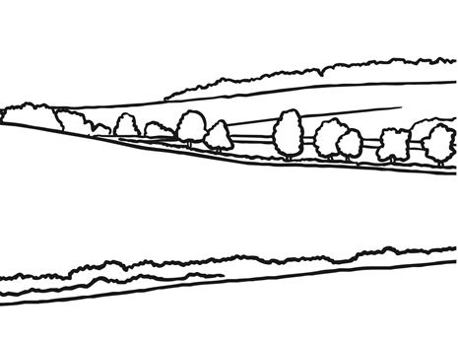  Countryside

Cut the pictures out carefully and stick them in the correct places in the table.

